SIMATS ENGINEERING
NAME: A.Preetika Sudhakar
REG NO. 192371073
COURSE NAME: Database Management Systems
COURSE CODE: CSA0501

Experiment No. 13
Simple Programming using CASE and LOOP

Aim
To learn how to use various MySQL loop statements including CASE and LOOP to run a block of code repeatedly based on a condition.

CASE Statement
The CASE statement has the functionality of an IF-THEN-ELSE statement.

LOOP Statement
The LOOP statement is used to repeatedly execute a block of statements. The loop is normally terminated using the LEAVE statement.

Program 1
Write a function using the CASE statement where:
- monthly_value <= 4000 → Low Income
- monthly_value <= 5000 → Avg Income
- Otherwise → High Income
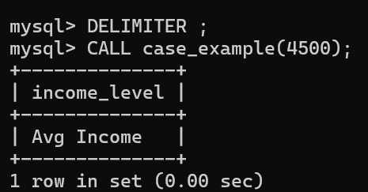
Next is Program 2 — LOOP + ITERATE, exactly as given in your lab manual. It repeats while income < 4000.
